Adding the ULPS Telehealth Email Account to your Email Account

Open the Outlook application on your desktop. This will not work on the OWA (Outlook Web Access through Molli)
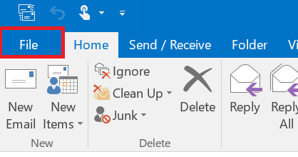
Click on File

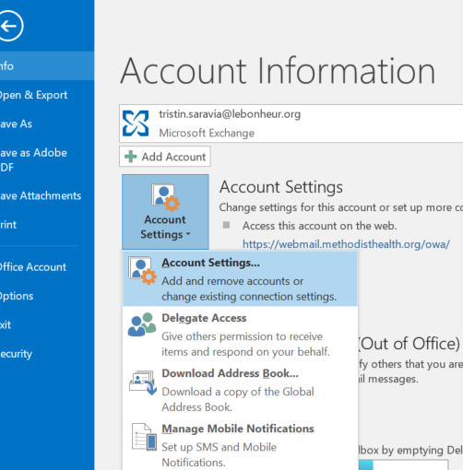
Click on Account Settings > Account Setttings…

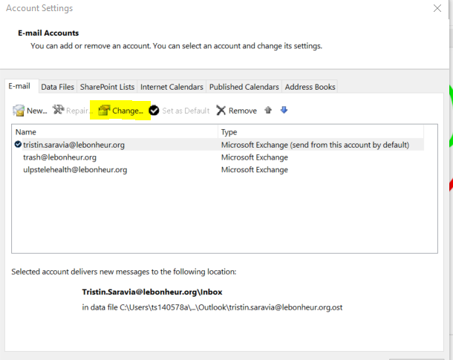

Click on “Change”

Click on “More Settings”
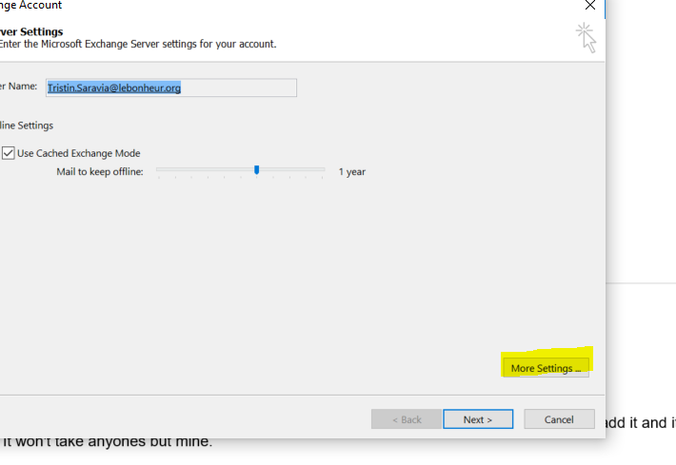
Click on Advanced, then click on “Add…”
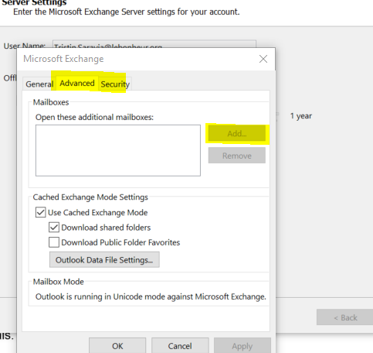

When the ADD dialog box pops up, type in: ulpstelehealth@lebonheur.org. Then click ok, apply, save, or finish whatever it asks you to do :)

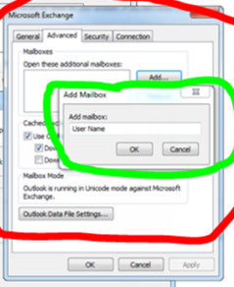

Then, close the application and reopen it

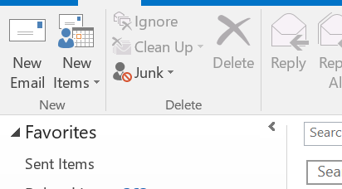
Click on New Email

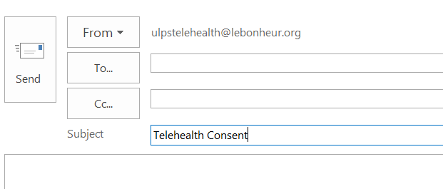
Type “Telehealth Consent in the subject line:

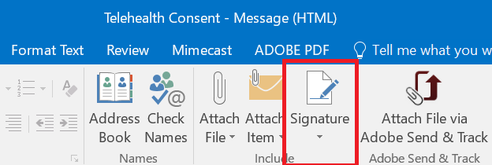
Then click on the Signatures icon

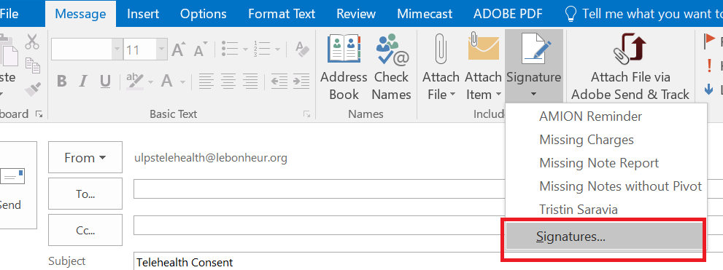
Then click on Signatures here

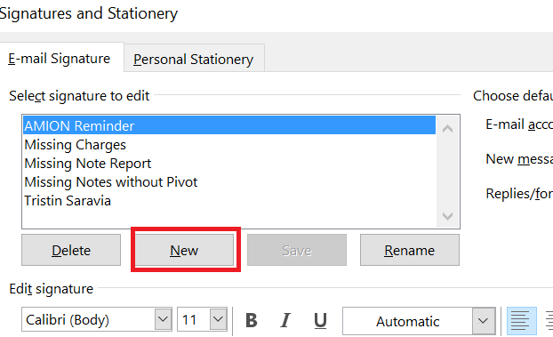
Select “New”

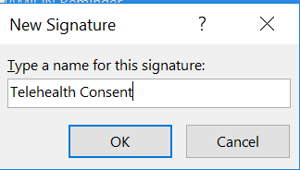
In the name box type “Telehealth Consent”
Then click “OK”

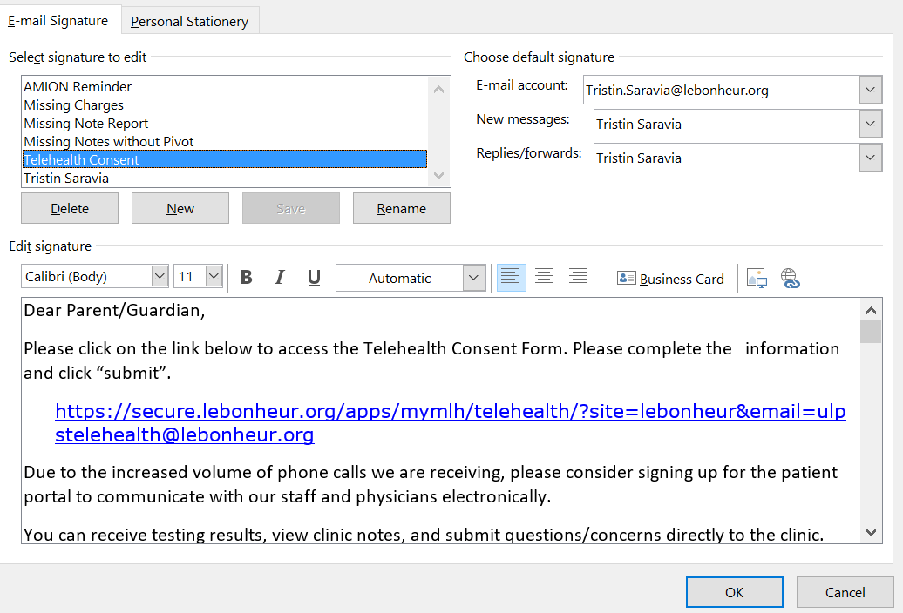
Copy and paste the language from the education for sending out the consent link into this text box.

Then click “OK”

Now you will able to choose this signature to auto-populate the Telehealth Consent email into your emails instead of pasting it in each time.
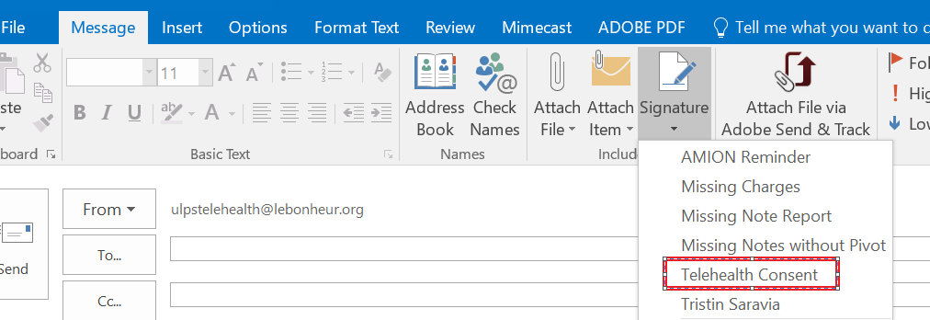

Enter the recipient’s email address and click “Send”
