Connecting to Your Provider Via Vidyo
Before Connecting:
- In order to connect, a consent to participate in telehealth is required.
- Your provider will email a link to complete the consent to you.
- Upon completion of the consent, your provider will send you a link to participate in your telehealth appointment.
From an Android or iPhone:
Requirements:
- WiFi or Cellular Data (this application can consume considerable data)
- Access to the email that the link was sent to from your phone
- NOTE: VidyoConnect will not work if you are on the phone when trying to connect.
Step 1: Download the VidyoConnect app from the app store.
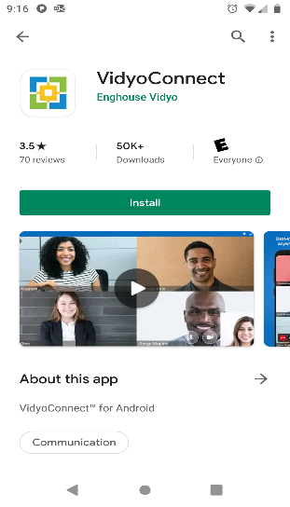
- If you open the app, it will ask for a portal and login.
- You will not need any of this information to connect.
- The only requirement is to have the app on your phone which will launch when you click the link.
Step 2: Click the link in your email.
- The app should open and connect.
- If you cannot see or hear the person that you are conferencing, be sure your speakers are turned up.
- If you haven’t another device or phone, call the person to see if they can assist in getting connected.
- NOTE: You cannot use the phone and VidyoConnect at the same time. The connection will fail if you attempt to do so.

