ULPS - Telehealth COVID-19 Process

# ULPS Physicians & Advanced Practice Providers

## Process

**To Establish an Account in Vidyo:**

1. Type <https://associates.telehealth.methodisthealth.org> into your web browser.
2. Install **VidyoConnect** to your computer by hitting “Run”. Once you download it, it becomes an icon on your desktop.
   1. **Portal: associates.telehealth.methodisthealth.org**
   2. **Username: Computer/Cerner log on**
   3. **Password: Cerner password**
3. This can be done from *any computer, phone, or iPad.* The device does not have to be an MLH device.
   1. An MLH device will have the strongest internet connection when you’re on an MLH campus.
   2. If you are trying to use this on a Patient Safe phone, you must turn off the WiFi and use the Verizon network for best results.

**Documenting the Visit:**

#### Facilitator of telehealth call (i.e., nurse, MA, etc.)

1. The person initiating the call should go to Documentation > PowerNote > Choose “Telehealth Note” type > Choose Telehealth Note encounter pathway template.  
   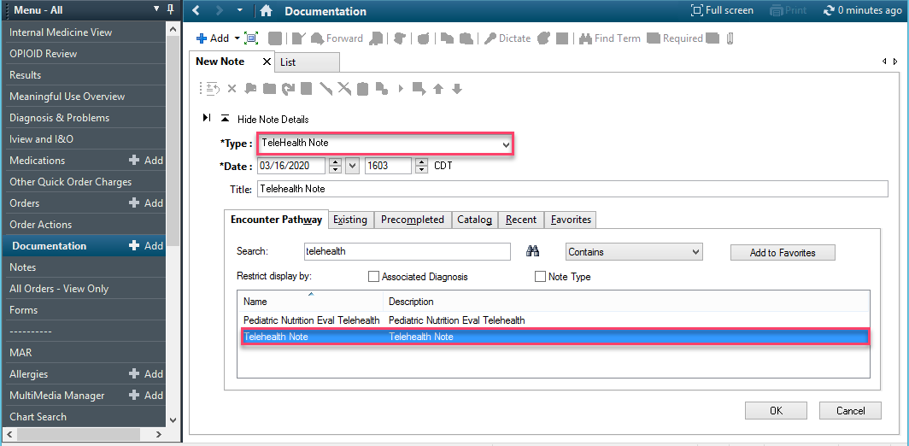
2. Document all necessary information, and Sign/Submit.
3. To choose consulting physician location (attending physician), click on the three small blue dots. Consulting physician location should always be “Le Bonheur Children’s Hospital”  
   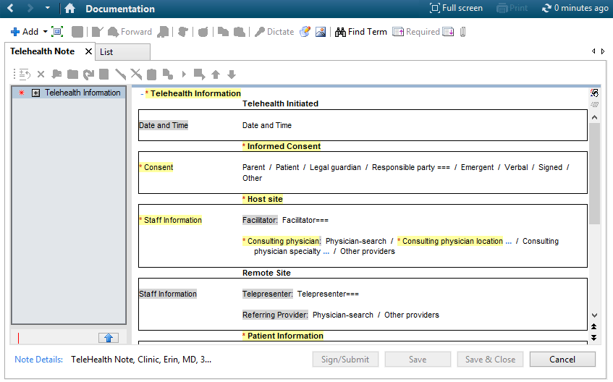
4. Go to Pediatric Ambulatory Intake Form and perform/document as much of your routine intake as possible. Sign the note.

#### Physician/APP Documentation

1. Physicians should use their regular note types from clinic (i.e. Cardiology Clinic Visit Note) but should indicate in the **Title** line that it’s a telehealth note. (i.e. “Cardiology Telehealth Note”) AUTOTEXT:
2. An auto-text is available to add to your note regarding COVID-19. Type **//z_tele_home**.

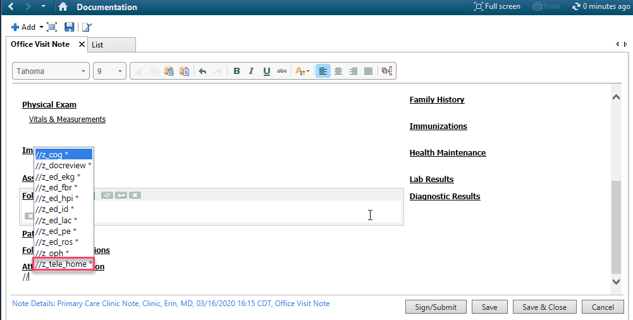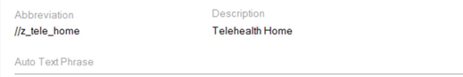



1. When entering your charges, add the modifier **GT**. This is old, but you can still access it. This will allow the charges to be managed on the back-end for compliance purposes so payers will pay the charges.
   1. The order sentence that include the GT modifier has been added to every division’s QOC page in Cerner.
2. You do **NOT** need to choose the telehealth Performing Discipline.  
   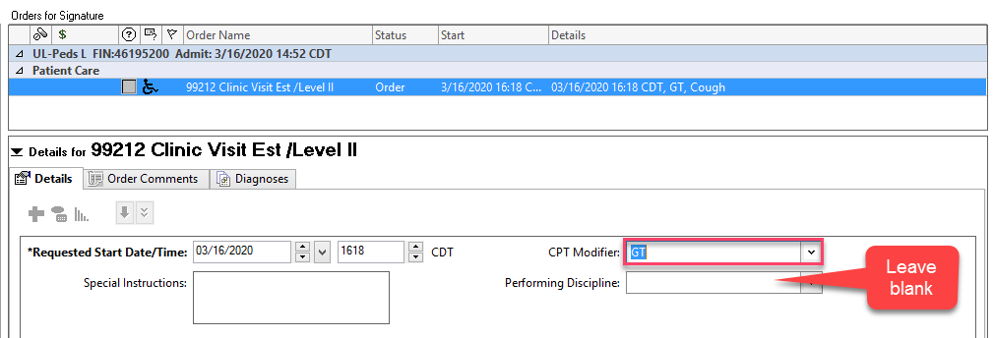

* 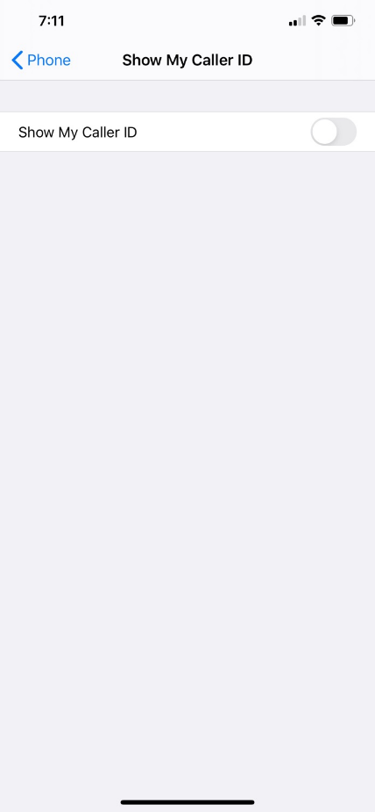If you are at home and need to call a patient, you can “hide” your personal iPhone cell number so it shows **Restricted**.   
  Settings>Phone>Show My Caller ID>Toggle switch to hide
* When performing a telehealth visit, it is important not only to maintain the privacy of the patient on the telehealth video conference, but also any patients in view of the camera used by the provider.
* **YOU MUST ALWAYS hang up the call when it is complete by clicking the red phone on the left. If you do not hang up, you will not be able to receive an invite for the next appointment.**

For assistance with the process, you can contact the clinical informaticists:

Raven McBride at [Raven.McBride@mlh.org](mailto:Raven.McBride@mlh.org) or (901) 354-4749.

Angel Davis at [Angel.Davis@mlh.org](mailto:Angel.Davis@mlh.org) or (901) 569-5605.

Jaleesa Larry at [Jaleesa.Larry@mlh.org](mailto:Jaleesa.Larry@mlh.org) or (901) 297-2495.

For troubleshooting connectivity issues during the visit, you can contact the Le Bonheur Transfer Center at (901) 287-4408.

Any additional billing FAQ is also available for your view.